Default Report
Marketing Research Survey
August 3rd 2018, 4:33 pm MDT
1. - What is your gender?
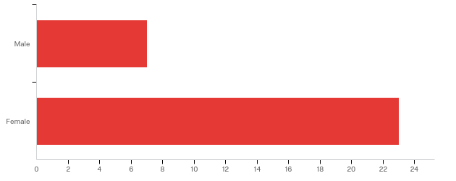

# | Field | Minimum | Maximum | Mean | Std Deviation | Variance | Count
1 | What is your gender? | 1.00 | 2.00 | 1.77 | 0.42 | 0.18 | 30

# | Answer | % | Count
1 | Male | 23.33% | 7
2 | Female | 76.67% | 23
 | Total | 100% | 30

2. - What is your ethnicity?
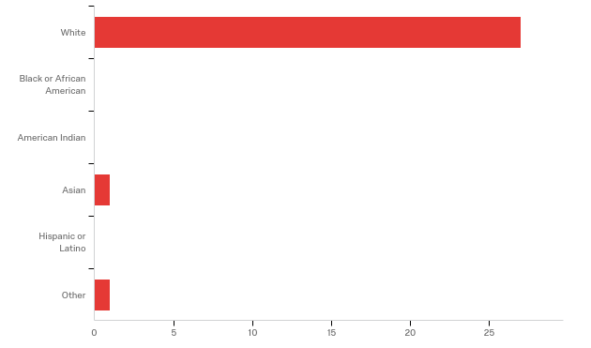

# | Field | Minimum | Maximum | Mean | Std Deviation | Variance | Count
1 | What is your ethnicity? | 1.00 | 6.00 | 1.28 | 1.05 | 1.10 | 29

# | Answer | % | Count
1 | White | 93.10% | 27
2 | Black or African American | 0.00% | 0
3 | American Indian | 0.00% | 0
4 | Asian | 3.45% | 1
5 | Hispanic or Latino | 0.00% | 0
6 | Other | 3.45% | 1
 | Total | 100% | 29

3. - How old are you?
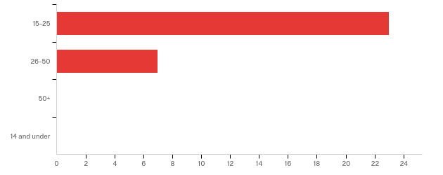

# | Field | Minimum | Maximum | Mean | Std Deviation | Variance | Count
1 | How old are you? | 1.00 | 2.00 | 1.23 | 0.42 | 0.18 | 30

# | Answer | % | Count
1 | 15-25 | 76.67% | 23
2 | 26-50 | 23.33% | 7
3 | 50+ | 0.00% | 0
4 | 14 and under | 0.00% | 0
 | Total | 100% | 30

4. - What state do you live in?

What state do you live in?
Utah
Utah
Utah
Utah
UT
Utah
Idaho
Utah
Utah
Utah
California
Idaho
Utah
Idaho
Idaho
Idaho
UT
Idaho
UTAH
Utah
Utah
Utah
Utah
Utah
Utah!
Utah
Idaho
Idaho
Utah
Utah

5. - What is your education level?
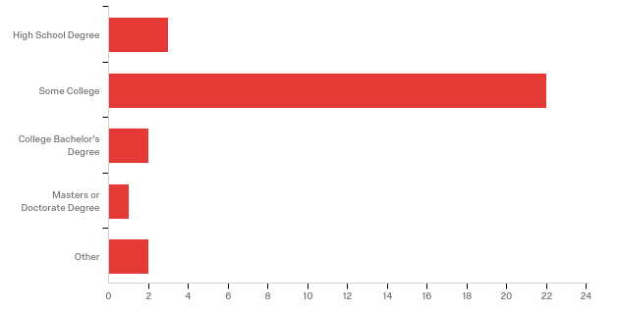

# | Field | Minimum | Maximum | Mean | Std Deviation | Variance | Count
1 | What is your education level? | 1.00 | 5.00 | 2.23 | 0.92 | 0.85 | 30

# | Answer | % | Count
1 | High School Degree | 10.00% | 3
2 | Some College | 73.33% | 22
3 | College Bachelor's Degree | 6.67% | 2
4 | Masters or Doctorate Degree | 3.33% | 1
5 | Other | 6.67% | 2
 | Total | 100% | 30

6. - What is your income level?
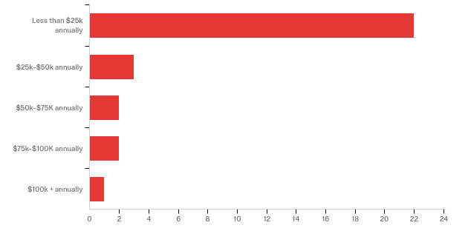

# | Field | Minimum | Maximum | Mean | Std Deviation | Variance | Count
1 | What is your income level? | 1.00 | 5.00 | 1.57 | 1.09 | 1.18 | 30

# | Answer | % | Count
1 | Less than $25k annually | 73.33% | 22
2 | $25k-$50k annually | 10.00% | 3
3 | $50k-$75K annually | 6.67% | 2
4 | $75k-$100K annually | 6.67% | 2
5 | $100k + annually | 3.33% | 1
 | Total | 100% | 30

7. - What is your relationship status?
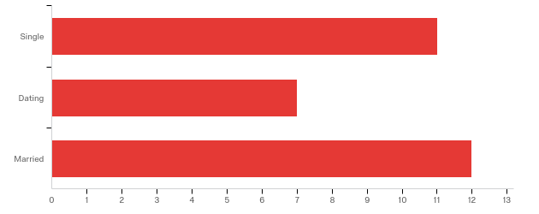

# | Field | Minimum | Maximum | Mean | Std Deviation | Variance | Count
1 | What is your relationship status? | 1.00 | 3.00 | 2.03 | 0.87 | 0.77 | 30

# | Answer | % | Count
1 | Single | 36.67% | 11
2 | Dating | 23.33% | 7
3 | Married | 40.00% | 12
 | Total | 100% | 30

8. - If married, do you have children?
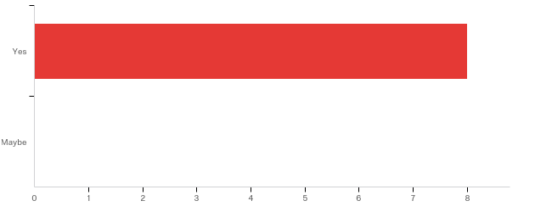

# | Field | Minimum | Maximum | Mean | Std Deviation | Variance | Count
1 | If married, do you have children? | 1.00 | 1.00 | 1.00 | 0.00 | 0.00 | 8

# | Answer | % | Count
1 | Yes | 100.00% | 8
2 | Maybe | 0.00% | 0
 | Total | 100% | 8

9. - When it comes to meals, is food quantity or food quality more important to you?
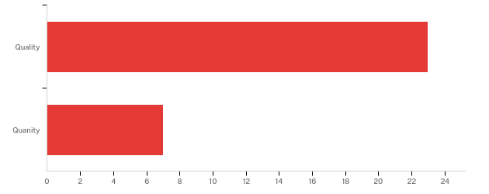

# | Field | Minimum | Maximum | Mean | Std Deviation | Variance | Count
1 | When it comes to meals, is food quantity or food quality more important to you? | 1.00 | 2.00 | 1.23 | 0.42 | 0.18 | 30

# | Answer | % | Count
1 | Quality | 76.67% | 23
2 | Quanity | 23.33% | 7
 | Total | 100% | 30

10. - Are fast food restaurants family friendly?
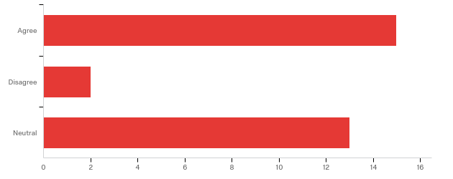

# | Field | Minimum | Maximum | Mean | Std Deviation | Variance | Count
1 | Are fast food restaurants family friendly? | 1.00 | 3.00 | 1.93 | 0.96 | 0.93 | 30

# | Answer | % | Count
1 | Agree | 50.00% | 15
2 | Disagree | 6.67% | 2
3 | Neutral | 43.33% | 13
 | Total | 100% | 30

11. - Do fast food chains contribute to negative health effects such as obesity?
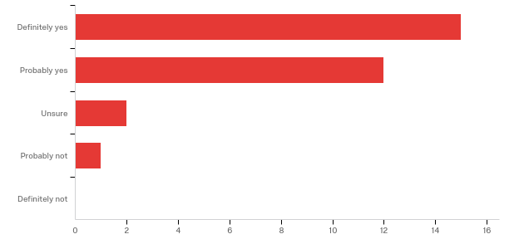

# | Field | Minimum | Maximum | Mean | Std Deviation | Variance | Count
1 | Do fast food chains contribute to negative health effects such as obesity? | 1.00 | 4.00 | 1.63 | 0.75 | 0.57 | 30

# | Answer | % | Count
1 | Definitely yes | 50.00% | 15
2 | Probably yes | 40.00% | 12
3 | Unsure | 6.67% | 2
4 | Probably not | 3.33% | 1
5 | Definitely not | 0.00% | 0
 | Total | 100% | 30

12. - Would you say most people are concerned about getting healthier food in fast food restaurants?
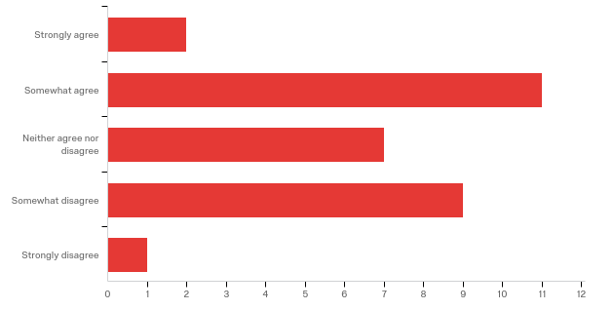

# | Field | Minimum | Maximum | Mean | Std Deviation | Variance | Count
1 | Would you say most people are concerned about getting healthier food in fast food restaurants? | 1.00 | 5.00 | 2.87 | 1.02 | 1.05 | 30

# | Answer | % | Count
1 | Strongly agree | 6.67% | 2
2 | Somewhat agree | 36.67% | 11
3 | Neither agree nor disagree | 23.33% | 7
4 | Somewhat disagree | 30.00% | 9
5 | Strongly disagree | 3.33% | 1
 | Total | 100% | 30

13. - In what situation do most people tend to eat fast food? SELECT YOUR TOP 3 ANSWERS
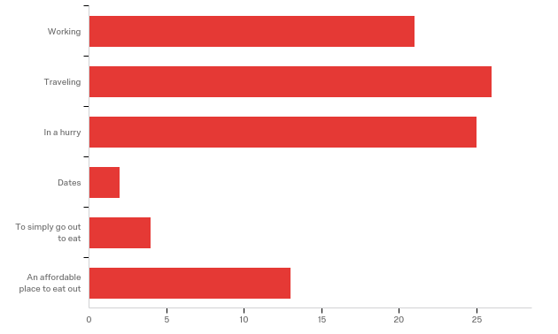

# | Answer | % | Count
1 | Working | 23.08% | 21
2 | Traveling | 28.57% | 26
3 | In a hurry | 27.47% | 25
4 | Dates | 2.20% | 2
5 | To simply go out to eat | 4.40% | 4
6 | An affordable place to eat out | 14.29% | 13
 | Total | 100% | 91

14. - What incentive brings you to your fast food restaurant of choice? RANK ORDER QUESTION
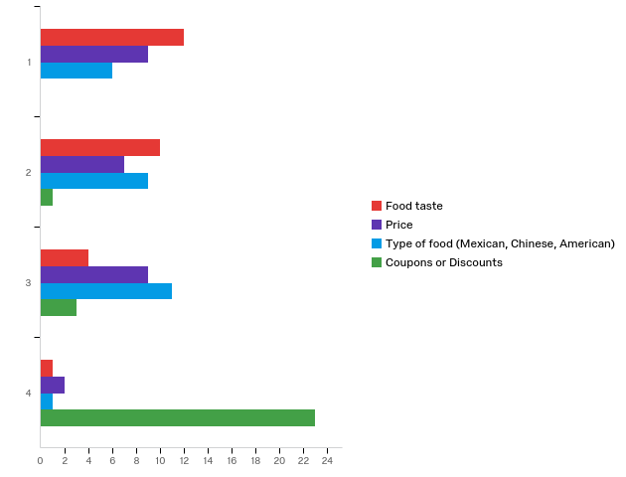

# | Field | Minimum | Maximum | Mean | Std Deviation | Variance | Count
1 | Food taste | 1.00 | 4.00 | 1.78 | 0.83 | 0.69 | 27
2 | Price | 1.00 | 4.00 | 2.15 | 0.97 | 0.94 | 27
3 | Type of food (Mexican, Chinese, American) | 1.00 | 4.00 | 2.26 | 0.84 | 0.71 | 27
4 | Coupons or Discounts | 2.00 | 4.00 | 3.81 | 0.47 | 0.22 | 27

# | Question | 1 |  | 2 |  | 3 |  | 4 |  | Total
1 | Food taste | 44.44% | 12 | 37.04% | 10 | 14.81% | 4 | 3.70% | 1 | 27
2 | Price | 33.33% | 9 | 25.93% | 7 | 33.33% | 9 | 7.41% | 2 | 27
3 | Type of food (Mexican, Chinese, American) | 22.22% | 6 | 33.33% | 9 | 40.74% | 11 | 3.70% | 1 | 27
4 | Coupons or Discounts | 0.00% | 0 | 3.70% | 1 | 11.11% | 3 | 85.19% | 23 | 27

15. - How often do you eat out at fast food restaurants?
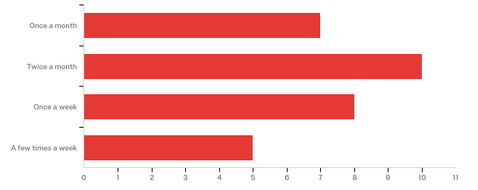

# | Field | Minimum | Maximum | Mean | Std Deviation | Variance | Count
1 | How often do you eat out at fast food restaurants? | 1.00 | 4.00 | 2.37 | 1.02 | 1.03 | 30

# | Answer | % | Count
1 | Once a month | 23.33% | 7
2 | Twice a month | 33.33% | 10
3 | Once a week | 26.67% | 8
4 | A few times a week | 16.67% | 5
 | Total | 100% | 30

